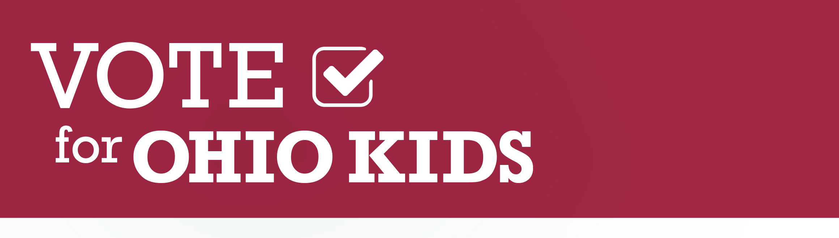

Sample Share Content

Brief Campaign Overview (great for Facebook/Blog/Newsletter):
[Insert organization here] is proud to be part of the Vote for Ohio Kids Coalition, a statewide effort dedicated to ensuring our next Governor will make investments in children’s early education and health a top priority. Today’s children are Ohio’s future workforce – and our next governor must ensure our youngest learners have proven high-quality early childhood experiences and access to the highest quality healthcare that leads to physical, developmental and mental wellness. If you’re interested in learning more about the Vote for Ohio Kids Campaign or want to get involved, visit VoteforOhioKids.org—and don’t forget to follow the campaign on Facebook and Twitter (@Vote4OhioKids).

Sample Twitter Posts:
[Insert organization here] is proud to be part of the @Vote4OhioKids coalition-- a statewide effort dedicated to ensuring our next Governor makes investments in children’s early education and health a top priority. Join this important effort at VoteforOhioKids.org/Join

It’s time to prioritize Ohio’s kids! Join us, along with business, healthcare, early education, and child advocacy leaders from across the state, in supporting the @Vote4OhioKids campaign by becoming part of the coalition at VoteforOhioKids.org/Join

Ohio’s next governor must invest in proven, high-quality early childhood education and support access to essential healthcare services for all Ohio kids. Join the @Vote4OhioKids coalition at VoteforOhioKids.org/join to ensure our next governor prioritizes Ohio kids!

Have you heard about the@Vote4OhioKids campaign? They’re working hard to ensure Ohio’s next governor prioritizes children’s early education and healthcare. Check out VoteforOhioKids.org to learn more and join the coalition!

@Vote4OhioKids is working to ensure our next governor makes Ohio kids a top priority. @MikeDeWine and @RichCordray – please participate in the #Vote4OhioKids Leadership Forum on 9/27 in Columbus to show your support for early healthcare and education! (VoteforOhioKids.org)

Quality early education & healthcare are a necessity for all Ohio families. It’s time for our next governor to step up and provide the quality resources our youngest Ohioans need to reach their full potential. @MikeDeWine @RichCordray @Vote4OhioKids (VoteforOhioKids.org)

Ohio kids can’t afford to wait another 4-8 years for our state to invest in quality early education and health care. We need to @Vote4OhioKids and make sure our youngest learners have the opportunity to grow up happy and healthy!

The evidence is clear—investments in quality early education and health for our youngest learners is good for families and for our state’s long-term economic success. Learn more about the case for early investments at VoteforOhioKids.org.

